Bittensor Subnet Analysis
- Bittensor Subnet
A subnet (short for subnetwork) is a specialized mini-network within the larger Bittensor ecosystem. Each subnet focuses on a specific type of tasks.
There are 127 subnets in Bittensor, and each one has its own specialized tasks and reward mechanisms.
Every subnet consists of 256 participants, including miners and validators. Miners earn rewards through incentives, which are determined by how well they perform their assigned tasks.
Registering as a miner requires spending TAO, and the registration cost varies across subnets. When a new miner joins, those with the lowest incentives—indicating poor performance or low-quality outputs—may be removed from the subnet. This means miners risk losing their stake and being rejected at any time if their performance is insufficient.
Each subnet also includes an immune period, which is a grace period after a miner first joins (or re-registers) a subnet. During this time, the miner is temporarily protected from being unweighted (i.e., scored very low) by validators.

- Bittensor Discord Channel
Bittensor has it’s discord group. You can chat with subnet owners, miners and validators on this channel.
Each subnet has own channel and owner announce the news, updates on the channel.
Miner can ask questions and check updates on the channel.
Join Link: https://discord.com/invite/WJuZU5jbRH

- Bittensor Explorer
TaoExplorer (often written as TAO Explorer) is a blockchain explorer for the Bittensor network — similar to how Etherscan works for Ethereum.
It allows you to view live on-chain data about the Bittensor ecosystem, including:
Subnets, Validators and miners, Wallet balances, TAO transactions, Block information, Incentives and weights
Link: https://www.tao.app/explorer

- TaoStats
Taostats.io (sometimes called TAO Stats or TaoExplorer) is the official analytics and explorer dashboard for the Bittensor network.
It’s a real-time blockchain explorer and analytics platform that provides insights into:
- Subnet performance
- Validator and miner activity
- TAO token emissions
- Wallet balances and transactions
- Staking and registration metrics
- Think of it like Etherscan + analytics dashboard for the Bittensor ecosystem.
Link: https://taostats.io/subnets/55/metagraph?order=type%3Adesc

- TaoMarketCap
TAO Market Cap is an unofficial analytics and market-tracking website dedicated to the Bittensor (TAO) ecosystem.
It focuses on financial and network statistics, similar to CoinMarketCap or DefiLlama, but specialized for TAO and its subnets.

What It Shows
Section Description
- TAO Token Metrics Real-time TAO price, circulating supply, total supply, market capitalization, and trading volume.
- Subnet Rankings Market-style ranking of all Bittensor subnets by TAO emission share, validator/miner counts, and total staked TAO.
- Emission Distribution Visual charts showing how TAO inflation (emissions) is split across subnets.
- Validator & Miner Data Statistics on active nodes, their rewards, and stake levels.
- TAO Price & History Historical charts of TAO’s price movements, emission rates, and staking trends.
- Economic Analytics Insights into total network value, staked-to-supply ratio, and other macro-level indicators.

- Zeus (Subnet 18)
  - Tasks
Zeus is Subnet 18 on the Bittensor network. Its purpose is decentralized environmental / climate / weather forecasting.
Miners in Zeus run forecasting models to predict environmental variables (e.g. weather conditions) at specific locations and times.

What Is ERA5?
ERA5 (short for ECMWF Reanalysis 5th Generation) is a global climate reanalysis dataset produced by the European Centre for Medium-Range Weather Forecasts (ECMWF).

It normally took 5 days to collect ERA5 data so we can not yesterday’s ERA5 data.

Time interval: 90s (Every 90s, miner get synapse data that include locations + time and need to send below 5 data with certain format)

Data needed:
- 2m temperature
- total precipitation
- 100m u component of wind
- 100m v component of wind
- 2m dewpoint temperature

Sampling weight: all are 0.2 (same weight)

  - Reward Logic
A small part of the incentive is currently based on response speed, incentiving miners to respond quickly.
The quality-based part of the reward function (substantial majority of the incentive) we use to evaluate miner performance is defined as below image.
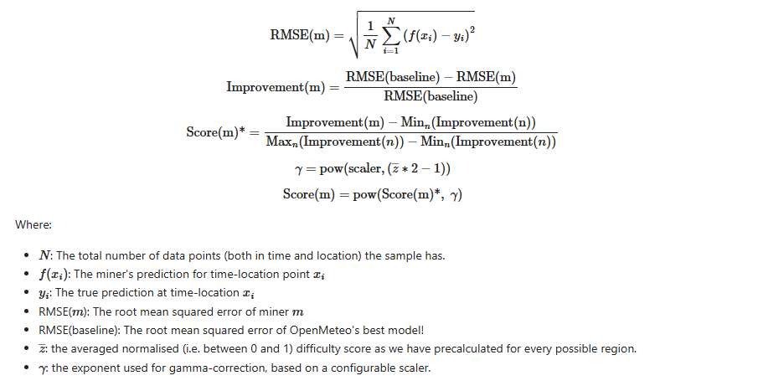

Baseline RMSE is calculated with data from openMeteo. OpenMeteo is free weather api that returns all locations of weather prediction data.
RMSE(m) is calcuated with data from ERA5.

  - Subnet analysis
- Subnet Total Miner A Day: 21.69 TAO
- Reg Cost: 0.56 TAO
- Top Miner Reward: 0.11

It’s reward is not high but can register multiple miners and can get high reward.
For example, 2 person register more than 70 miners and earn around 7 TAOs a day. But It’s impossible to prevent to kill the miner because of low performance.
It has high competitive fields.

  - What have done ?
- Microsoft Aurora Model
It’s weather forecasting model to predict the weather and it’s already has pre-trained with ERA5 data.
It’s model size is really huge.
It will take around 30 days to train the model and will take 7 days for fine-tune with A100 * 8 server.

It’s not profitable with model training so ignore this solution.
- Weather forecasting API
There are lots of weather forecasting apis(premium version) like
- meteomatics
- visualcrossing
- OpenMeteo

I used WeatherApi to forecast the weather data and it’s RMSE is not bad but it’s not better than top miners.
They register lots of miners in purpose of maximize the reward, so our miners rejected after immune period.
It means it get rewards in that time but rejected because of low performance than others.

Used lots of apis together to improve the performance but until not find the better solution.

- Mantis (Subnet 123)
  - Tasks
Predict 1 hour ahead of BTC price signal every seconds.
  - Reward Logic
- Assets
"BTC", "ETH", "EURUSD", "GBPUSD", "CADUSD", "NZDUSD", "CHFUSD", "XAUUSD", "XAGUSD"
- Dims
BTC: 100, others: 2

Every seconds miner needs to send 116 dims of prediction results.
The validator stores the results of inference using the xboost model, including all miner data. It then deletes only the miner's data and reruns the inference, distributing rewards based on the impact on accuracy.
  - Subnet analysis
- Subnet Total Miner A Day: 27.95 TAO
- Reg Cost: 0.11 TAO
- Top Miner Reward: 1.71

Owner said that currently top miner’s accuracy is around 62 %.
The rewards calculated based on history datasets, it’s not easy to get rewards for new miners.
Tried several times to register miners but failed to get rewards.
  - What have done ?
Used AI models to predict next 1 hour Asset price signal but failed to get rewards.
It is because new miner has low history data and it does not effect much to the whole accuracy of model.

- Precog (Subnet 55)
  - Tasks
BTC, ETH and TAO price prediction of next 1 hour for every 5 minutes.
  - Reward Logic
Reward = Point Score + Interval Score / 2

Point Score = 0.8 ^Rank(point value of miner)
Point value = abs(CM price - prediction price)

Interval Score = 0.8^Rank(interval value of miner)
Interval value = FI * FW
FI = min(pred_max, real_max) - max(pred_min, real_min) / max(pred_max, real_max) - min(pred_min, real_min)
FW = count of (ASSET price include in [pred_min, pred_max]) / total_count
  - Subnet analysis
- Subnet Total Miner A Day: 6.35 TAO
- Reg Cost: 0.18 TAO
- Top Miner Reward: 0.11

Implement AI models for prediction BTC, ETH and TAO 1 hour head prices in every 5 mins and low_1h & high_1h of all assets.
Current register 4 miners and it’s total reward is 0.2 TAO.
  - Result
It’s also very competitive and not easy to kill the miner.
Regcost also get higher because lots of people register miners everyday.

- How to create miner ?
https://github.com/coinmetrics/precog?tab=readme-ov-file

